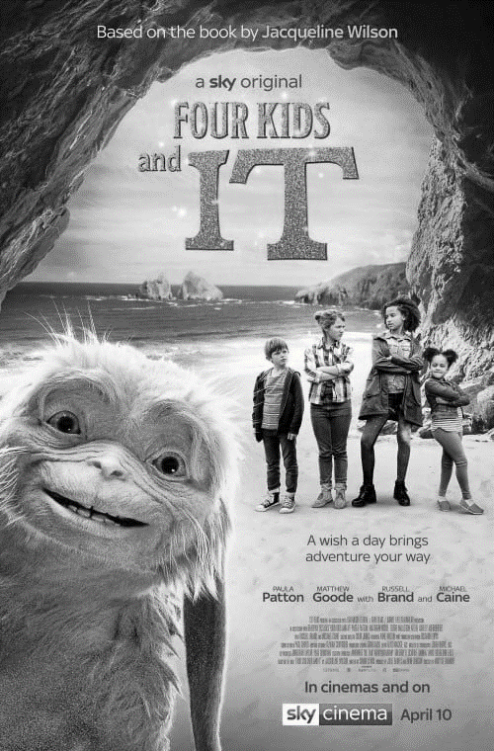

The title **font** is in **bold**,tall **capitals**, in the **genre** of adventure movies. The title is **framed** by the rocks and the **white space** of the sky, drawing **focus** to it. **Focus** is also drawn to “IT”, who is **positioned** in the bottom left, by its outline being **highlighted** with light. **Balancing** this, the four kids are on the right, and in **contrast** they are in the middle distance.

|  |  |  |  |
| --- | --- | --- | --- |
| **D** | **Key Vocab** | | |
|  | | **Contrast** | **Bold** |
|  | | **Emphasise** | **Capitals** |
|  | | **Framing** | **Classic** |
|  | | **Highlight** | **Simple** |
|  | | **Symmetry** | **Genre** |
|  | | **Centred** | **Target audience** |
|  | | **Perspective** |
|  | |  |  |
|  | |  | |
|  | |  | |
|  | |  | |
|  | |  | |
|  | |  | |
|  | |  | |
|  | |  | |
|  | |  | |
|  | |  | |

Name:

R082: Digital Graphics Uses and Content

|  |  |  |  |
| --- | --- | --- | --- |
| **B** | | **Design and Layout Vocab** | |
| **Colour** | | | |
| **1** | **Warm** | | Red, orange, yellow. Bright, energetic |
| **2** | **Cool** | | Blue, green, purple. Settling and calm |
| **3** | **Neutral** | | Beige, cream, ivory. Avoids attention |
| **Composition** | | | How a digital graphic is set out, including: |
| **1** | **Positioning** | | Where objects are placed relative to each other |
| **2** | **Focus** | | How lines and perspective draw attention to certain areas |
| **3** | **Balance** | | Which parts are similar to each other and which parts contrast |
| **4** | **Font** | | Lettering style |
| **5** | **White space** | | Any block of solid colour where there are no elements |

|  |  |  |  |
| --- | --- | --- | --- |
| **C** | | **Purposes of Digital Graphics** | |
| **1** | **To entertain** | | To amuse or provide enjoyment |
| **2** | **To advertise** | | To promote a product |
| **3** | **To promote** | | To give publicity to an idea, person, company etc *(eg NHS health campaign)* |
| **4** | **To inform** | | To give information *(eg signage)* |
| **5** | **To educate** | | To give information and understanding about a topic *(eg infographic)* |

|  |  |  |  |
| --- | --- | --- | --- |
| **A** | | **Uses of Digital Graphics** | |
| **1** | **Print publishing** | | eg Magazines, leaflets, books, newspapers, posters |
| **2** | **Labelling** | | eg ingredients, health warnings, |
| **3** | **Branding** | | eg Logos, Trademark images |
| **4** | **Advertising** | | eg *printed:* billboards, poster eg *online:* banner ads |
| **5** | **Websites** | | eg backgrounds, borders, buttons |
| **6** | **Presentations** | | eg infographics |
| **7** | **Games** | | eg box covers, images used in-game |